Protocol for schools located in the London borough of Croydon to identify children missing education and to notify the LA of all starters and leavers
This document sets out the new requirements for identifying children missing education (CME) and to notify the LA of all starters and leavers. This is for the attention and action of all schools (including academies and independent schools) with pupils of statutory school age (5 – 16).
Background
With effect from 1st September 2016, all schools are required to notify the maintaining local authority of starters and leavers. This does not include those starting at the school at the first point of entry in Reception or Year 7, or those leaving Year 11.
The government amended the Education (Pupil Registration) (England) Regulations 2006 (“the Regulations”) to improve communication and co-ordination between schools and LAs. This includes academies and independent schools. The DfE statutory guidance can be found by clicking on the link below:
https://www.gov.uk/government/uploads/system/uploads/attachment_data/file/550416/Children_Missing_Education_-_statutory_guidance.pdf
Legal Requirements
The following applies to non-standard transition points, also referred to as ‘in-year’.
All schools will be legally required to:

- Inform the LA when they are about to delete a pupil’s name from the admission register under the permitted grounds relevant to children of statutory school age (these are shown on the Pupil Migration form attached);

- Record details of the pupil’s residence, the name of the person with whom they reside, the date from which they will reside there, and then name of the destination school (where they can reasonably obtain this information);

- Inform the LA of the pupil’s destination school and home address if the pupil is moving to a new school; and

- Provide information to the LA when registering new pupils, within five days, including the pupil’s address and previous school (where they can reasonably obtain this information).

Method of notification
All schools will be required to notify the LA of all starters and leavers as set out in the legal requirements above with immediate effect. The attached Pupil Migration form, which is in excel format, is provided for completion each week unless there are no starters or leavers to report, in this case the form must be completed monthly with a nil return.
All schools must return their Pupil Migration form using Egress Secure Email to PupilMigration@croydon.gov.uk.
Please use the following link to sign up to Egress to add a secure option to send emails from your email address: https://switch.egress.com/ui/registration/AccountCreate.aspx. There is no charge and it is quick to set up.
For schools who already complete migration reports please note the Pupil Migration form will replace those reports.

Requirements at standard transition points
Systems are already in place between schools and the LA to identify children that either do not accept a school offered to their child or do not turn up to the school for which they have been accepted and been placed on roll.
The School Admissions Team will monitor cases where a school place has not been secured at the standard point of entry (Reception and Year 7).
The School Admissions team are the point of contact for schools where pupils placed on a school roll have not arrived on their given start date.
Independent schools do not currently notify the LA of children that do not arrive on their given start date. To ensure the safeguarding responsibility is consistent with state maintained schools, it is requested that independent schools use the Pupil Migration form to notify the LA of children who have not arrived as expected. The school must have carried out their own checks before passing to the LA.

Year 12 & 13 starters and leavers

Legislation (ESA 2008) requires all post 16 providers to share monthly data about the learners who enter and leave their organisations with their Local Authority. This information helps the Local Authority to intervene more swiftly and hopefully help young people to get back into education or training. Information regarding this process is sent to all schools and colleges with sixth form provision annually in the summer term or can be obtained via 14-19Team@croydon.gov.uk

Instructions for using the Pupil Migration Form

Starters/Pending Admissions
Snapshot of the starter page.
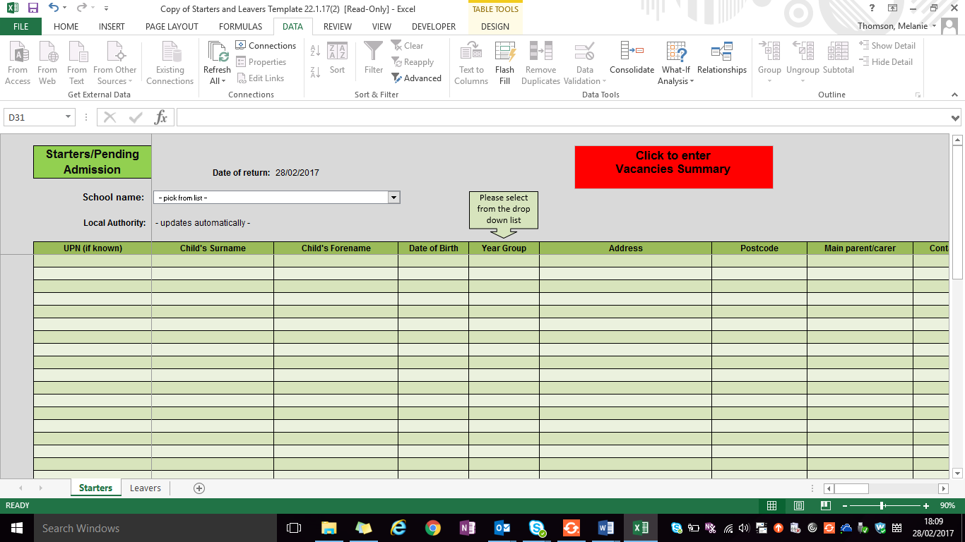

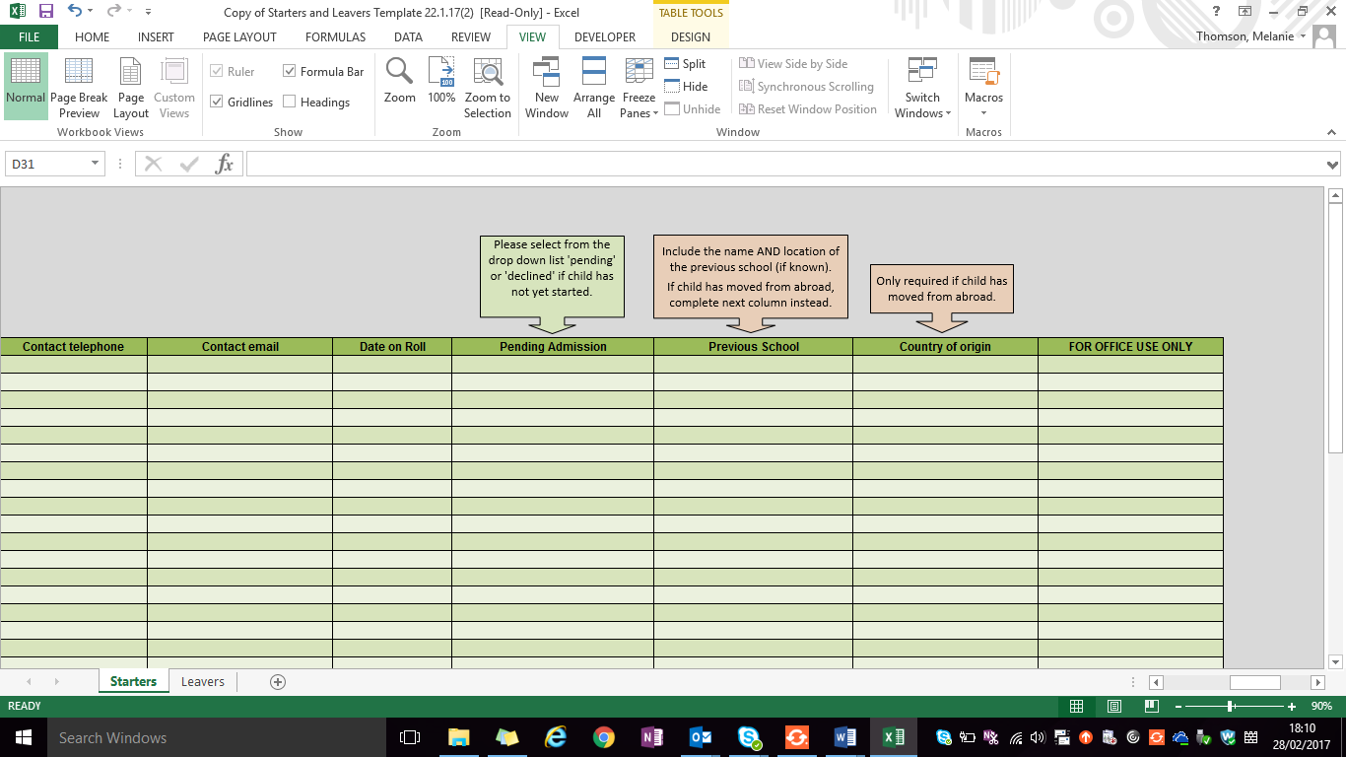

Please ensure that you also complete the ‘Vacancies Summary’ section of the Starters form:

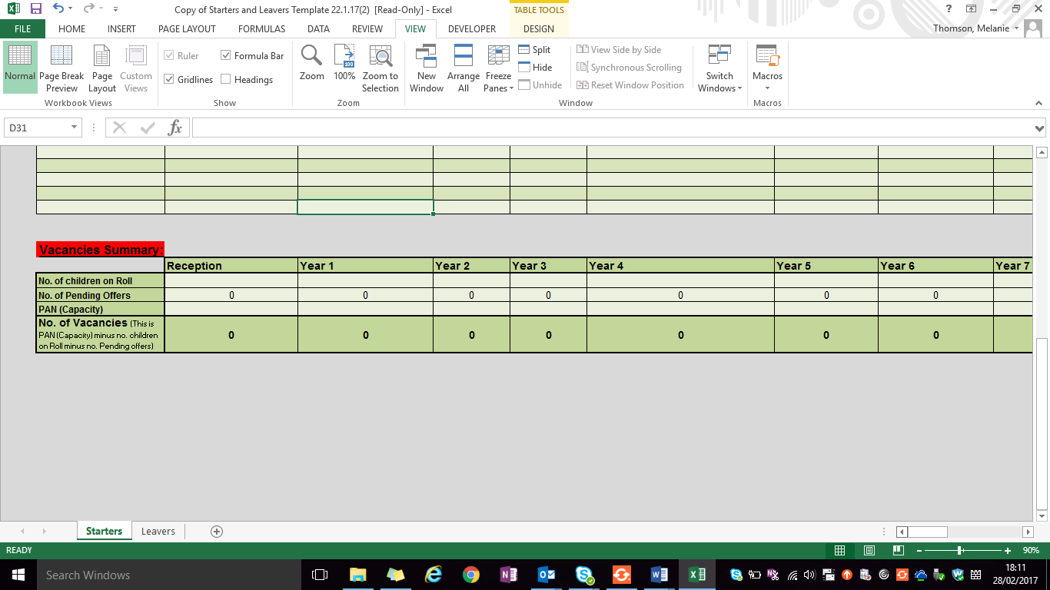
All schools will be required to provide the details as set out on the form for all new pupils they take on roll (for state schools this excludes reception and year 7).
Schools with an ELP must contact the School Admissions Team for a slightly amended version of the return.
Independent schools are asked to provide data for all their starters and leavers if school ends before Year 11. Reception and Year 7 starters should also be included to enable the LA to check against the data held by admissions to eliminate duplicate offers and to record where a child has taken up an Independent school but has failed to notify the LA.
Leavers
Snapshot of the leaver page
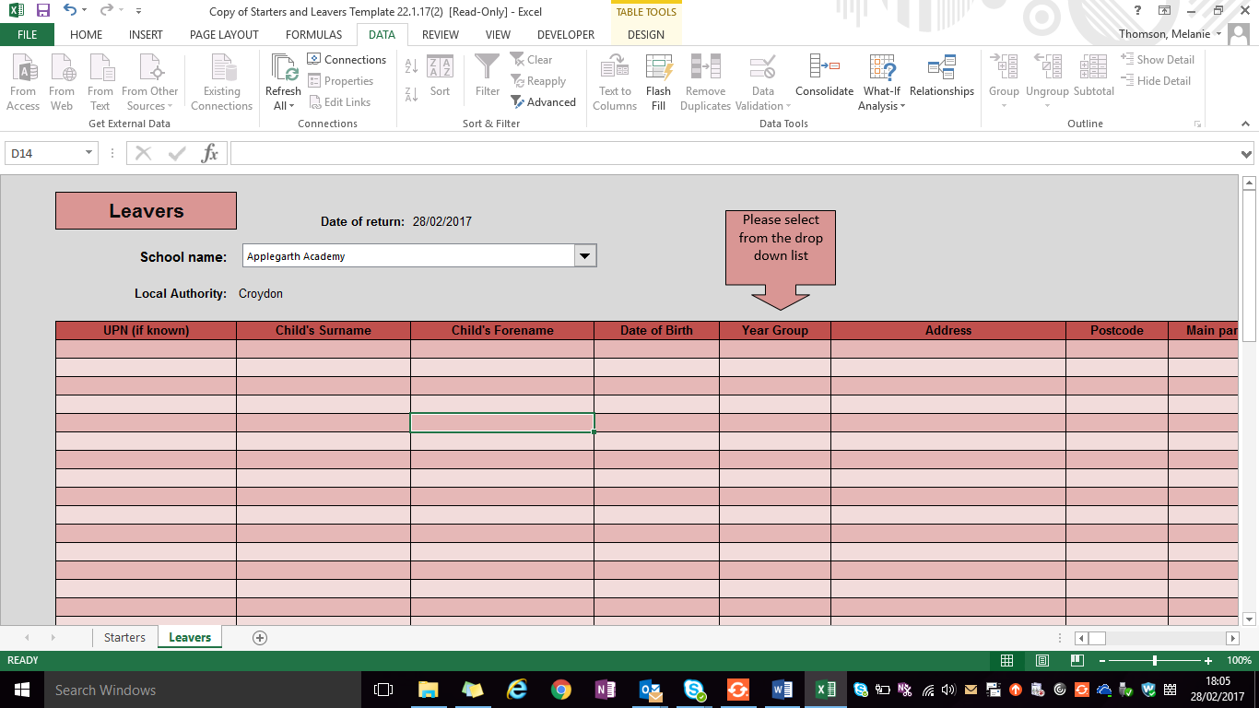

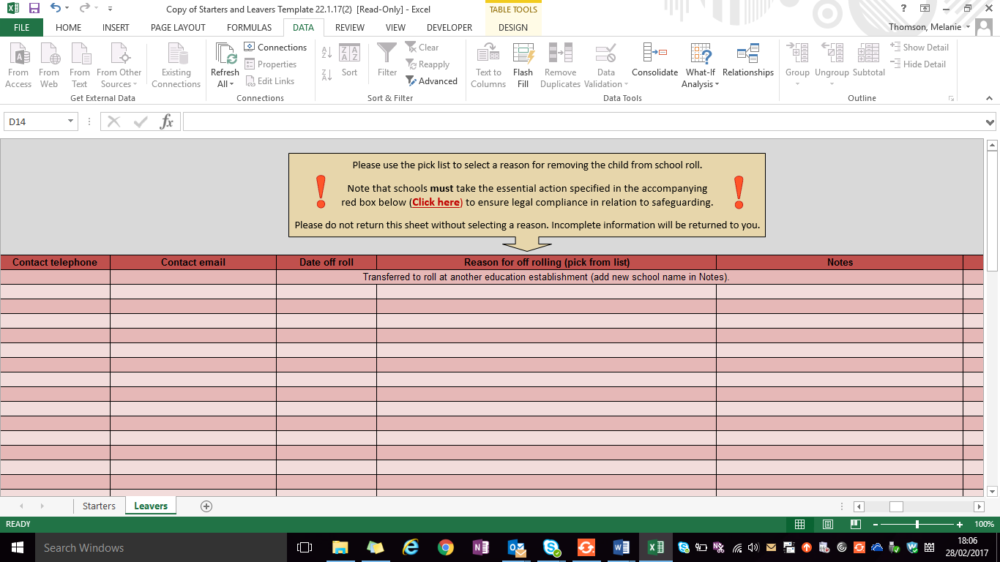
All schools will be required to provide the details as set out on the form for all pupils they take off roll (excluding children leaving at the end of year 11).
Independent schools are asked to provide leaver details for Year 6 and any other year group that their school provides education up to, if it ends before year 11.
A column must be completed for each pupil returned on this form. Schools cannot remove a child from their roll unless one of the grounds under regulation 8 of the ‘Education Pupil Registration Regulations’ for deleting a pupil from the admission register is met. Further advice can be found in “Croydon Missing Education Policy and Procedures.”

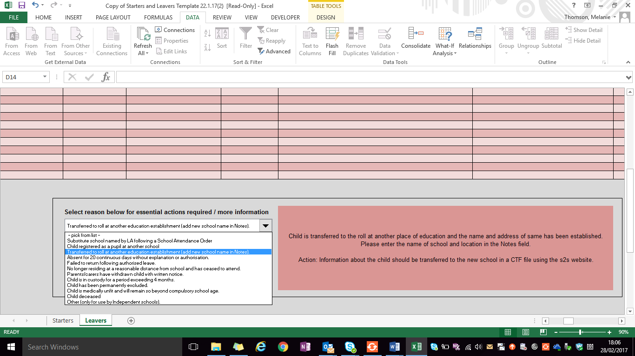

It is the responsibility of each school to ensure that all reasonable steps and appropriate action has been taken before removing a pupil from their roll. The action required is indicated in the box to the right of the drop down list.
As an example, it would not be sufficient for a school to remove a child from their roll if the parent has verbally informed them that they are moving to another area or abroad. The school would be expected to:
Record details of the pupil’s new residence and or country moving to, the name of the person with whom they reside, the date from which they will reside there, and the name of the destination school (where they can reasonably obtain this information).
Where a school has indicated ‘absent for 20 continuous days’ or ‘failed to return following authorised leave’, it would be expected that the case has been referred to the Education Welfare Service or CME officer to help carry out reasonable enquiries and it has been concluded that the child is ‘untraceable’.
The CME referral form must be completed and returned for all untraceable children on a school roll. (Please refer to the ‘Children Missing Education Policy and Procedures’ document).
When a school has indicated ‘Parents/carers have withdrawn child with written notice’ it will only be to educate their child otherwise than at school. A referral must be made to the Elective Home Education officer to ensure that the appropriate EHE process has been followed. (Please refer to the ‘Children Missing Education Policy and Procedures’ document).
The requirements apply to all children starting or leaving a school irrespective of their borough of residence. If the child resides outside of Croydon, you will need to pass the details via the Document Exchange to the respective LA. It is not clear at this early stage in the process whom in each LA has been delegated the responsibility of this new Regulation, this will become apparent over time. Until then, please send the details for the attention of the Admissions team or CME Officer as relevant.
Children with a statement of special educational needs/EHC plan
If a child has a statement/EHCP plan and attends a special school, the LA (SEND team) has to give permission for the child to be educated at home. The child must therefore remain on the school roll until permission has been granted by SEND to remove him/her from roll.
Information Sharing
All information is processed in accordance with the General Data Protection Regulation 2016 and Data Protection Act 2018.
The processing of personal information is necessary for:
- Compliance with a legal obligation (Article 6.1(c)) and/or
- The performance of a task carried out in the public interest (Article 8.1(e)).
The processing of special category information is necessary for:
- The purpose of carrying out obligations in the field of social protection law (Article 9.2(b)); or
- The establishment, exercise or defence of legal claims (Article 9.2(f); or
- Reasons of substantial public interest (Article 9.2(g). In particular it is necessary for the purposes of exercising a function conferred on the Council by an enactment (Statutory and government purposes – Data Protection Act 2018 - Schedule 1, Part 2, paragraph 6(2)(a)).
As noted above, Croydon Council has a duty to ensure that children within its boundaries are being appropriately educated, and it is necessary for this function that we obtain this information.

Updated: September 2019

