OLD COULSDON
2018 - 2019 Ward Report
Councillors Bird, Hollands

This report provides a summary of the 2018/19 community ward spend, highlighting some of outcomes in line the Council’s Corporate Plan commitment and wider approach to a refreshed Community Voluntary Strategy.
Summary:
A total of £15,922.27allocated, with the remaining balance of £77.73 being carried forward to 2019/20 spend. Allocation of Funding is analysed under 6 categories – i.e. a) Children & Young People b) Health and Well-being c) Culture Sports & Arts d) Work & Career e) Environment & Parks. This has been colour coded for ease of reference and the key is provided below.

KEY
Culture Sports & Arts Activities
Work & Career
Children & Young People
Environment & Parks
Safer Neighbor Hoods
Health & Wellbeing

Projects Funded | Outcome Achieved | Amount Awarded
17TH PURLEY SCOUT GROUP | To provide roofing materials for the shed to house camping equipment  Keep camping equipment and supplies dry and ready for camping season. | £488.00
BRADMORE POND VOLUNTEER'S TOOLS | To provide replacement tools for volunteer workers in the pond | £500.00
CROYDON BOROUGH NEIGHBOURHOOD WATCH | Fund the Old Coulsdon ward version of the Borough-wide ‘Good Neighbour Guide’ | £1,000.00
CHRISTMAS LIGHTS IN OLD COULSDON FRIENDS GROUP | Lighting up Old Coulsdon at Christmas. £2500 towards new lights. Switch on £21 for TENS licence and £156 for road closure  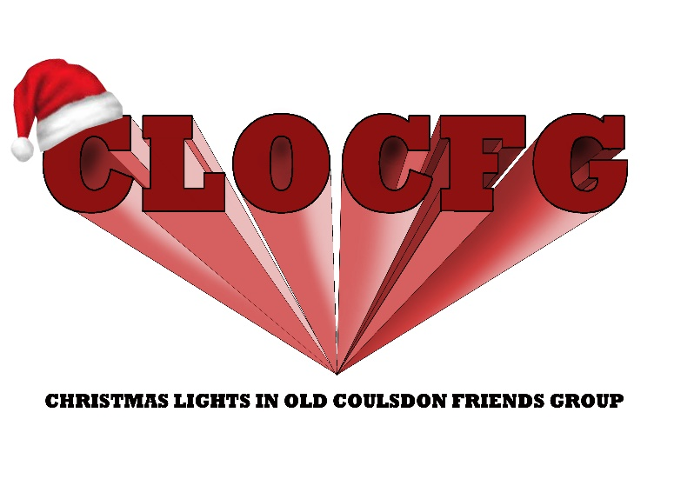  NOVEMBER 24th  CHRISTMAS LIGHTS SWITCH ON  4.15pm LACEY GREEN PARADE  5pm TUDOR PARADE  CAROL SINGING, MULLED WINE , SANTA’S GROTTO, BBQ, SCOUTS, GUIDES, BUNTY’S AIRSTREAM, POLICE, LONDON FIRE BRIGADE, BARREL ORGAN, ROTARY STEWARDING  FROM 4PM-6PM ON COURT AVENUE  (COULSDON ROAD END)  Parking available in Coulsdon College Placehouse Lane until 7pm | £2,677.00
CROYDON HEARING RESOURCE CENTRE | To assist fund the open monthly surgery in Old Coulsdon for 159 clients (126 actually seen last year) living in the ward residents and home visits (currently 15) to check the tubing in hearing aids are in good condition | £400.00
DAVID LEAN CINEMA- DEMENTIA FRIENDLY SCREENING | These Dementia Friendly screenings aim to make cinema more accessible by providing a fun and inclusive experience to enable people living with dementia, their families and carers to attend the cinema in a safe and welcoming environment. The lights are left on low, there are no adverts or trailers and the audience is allowed to move around or even sing along to any musical numbers if they’d like to. 2 screenings have taken place  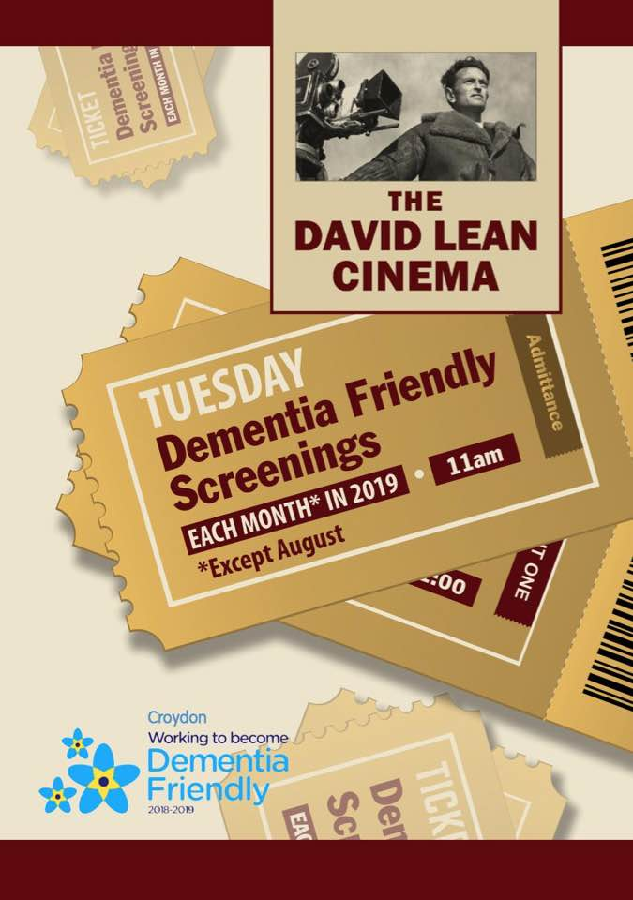 | £400.00
EAST COULSDON RESIDENTS ASSOCIATION | To cover legal costs associated with the transfer of Coulsdon Memorial Ground to Fields In Trust and also towards the new notice board and any other associated costs for the project.As a local initiative by residents, Coulsdon Memorial Ground is in the process of transferring to Fields in Trust as part of the commemoration of the end of the World War I. The transfer of land will help protect the land for generations to come. We were asked by East Coulsdon Residents Association (ECRA) if we would cover the legal costs. £2,000 of our Community Budget was used to fund the majority of the legal transfer costs between Croydon Council and Fields in Trust. Our councillor colleagues in Coulsdon Town also contributed towards the costs. The new sign is now up in the park and there is a plague to follow.  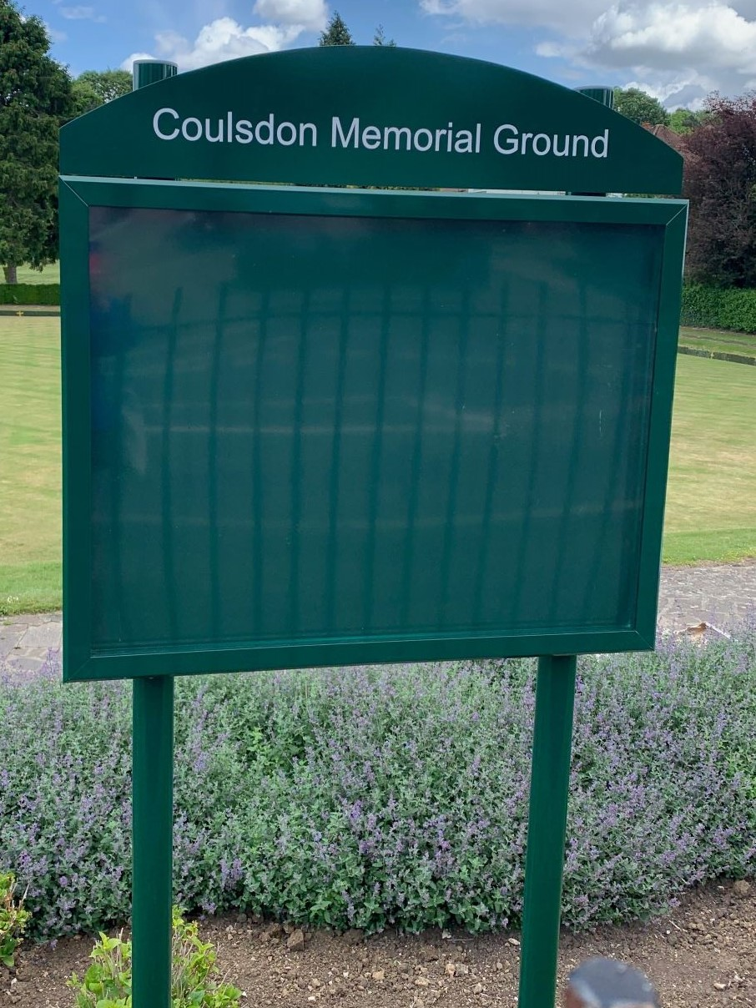 | £2,000.00
FRIENDS OF FARTHING DOWNS & HAPPY VALLEY | Contribution towards replacing rotten way sign on Farthing Downs- New way sign showing walkers and families directions. Now in-situ per photos  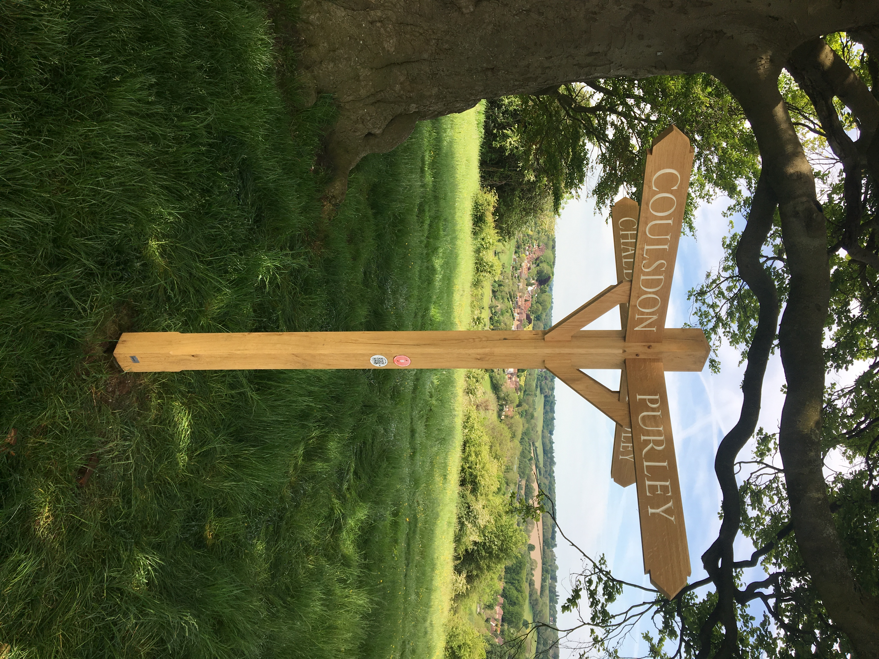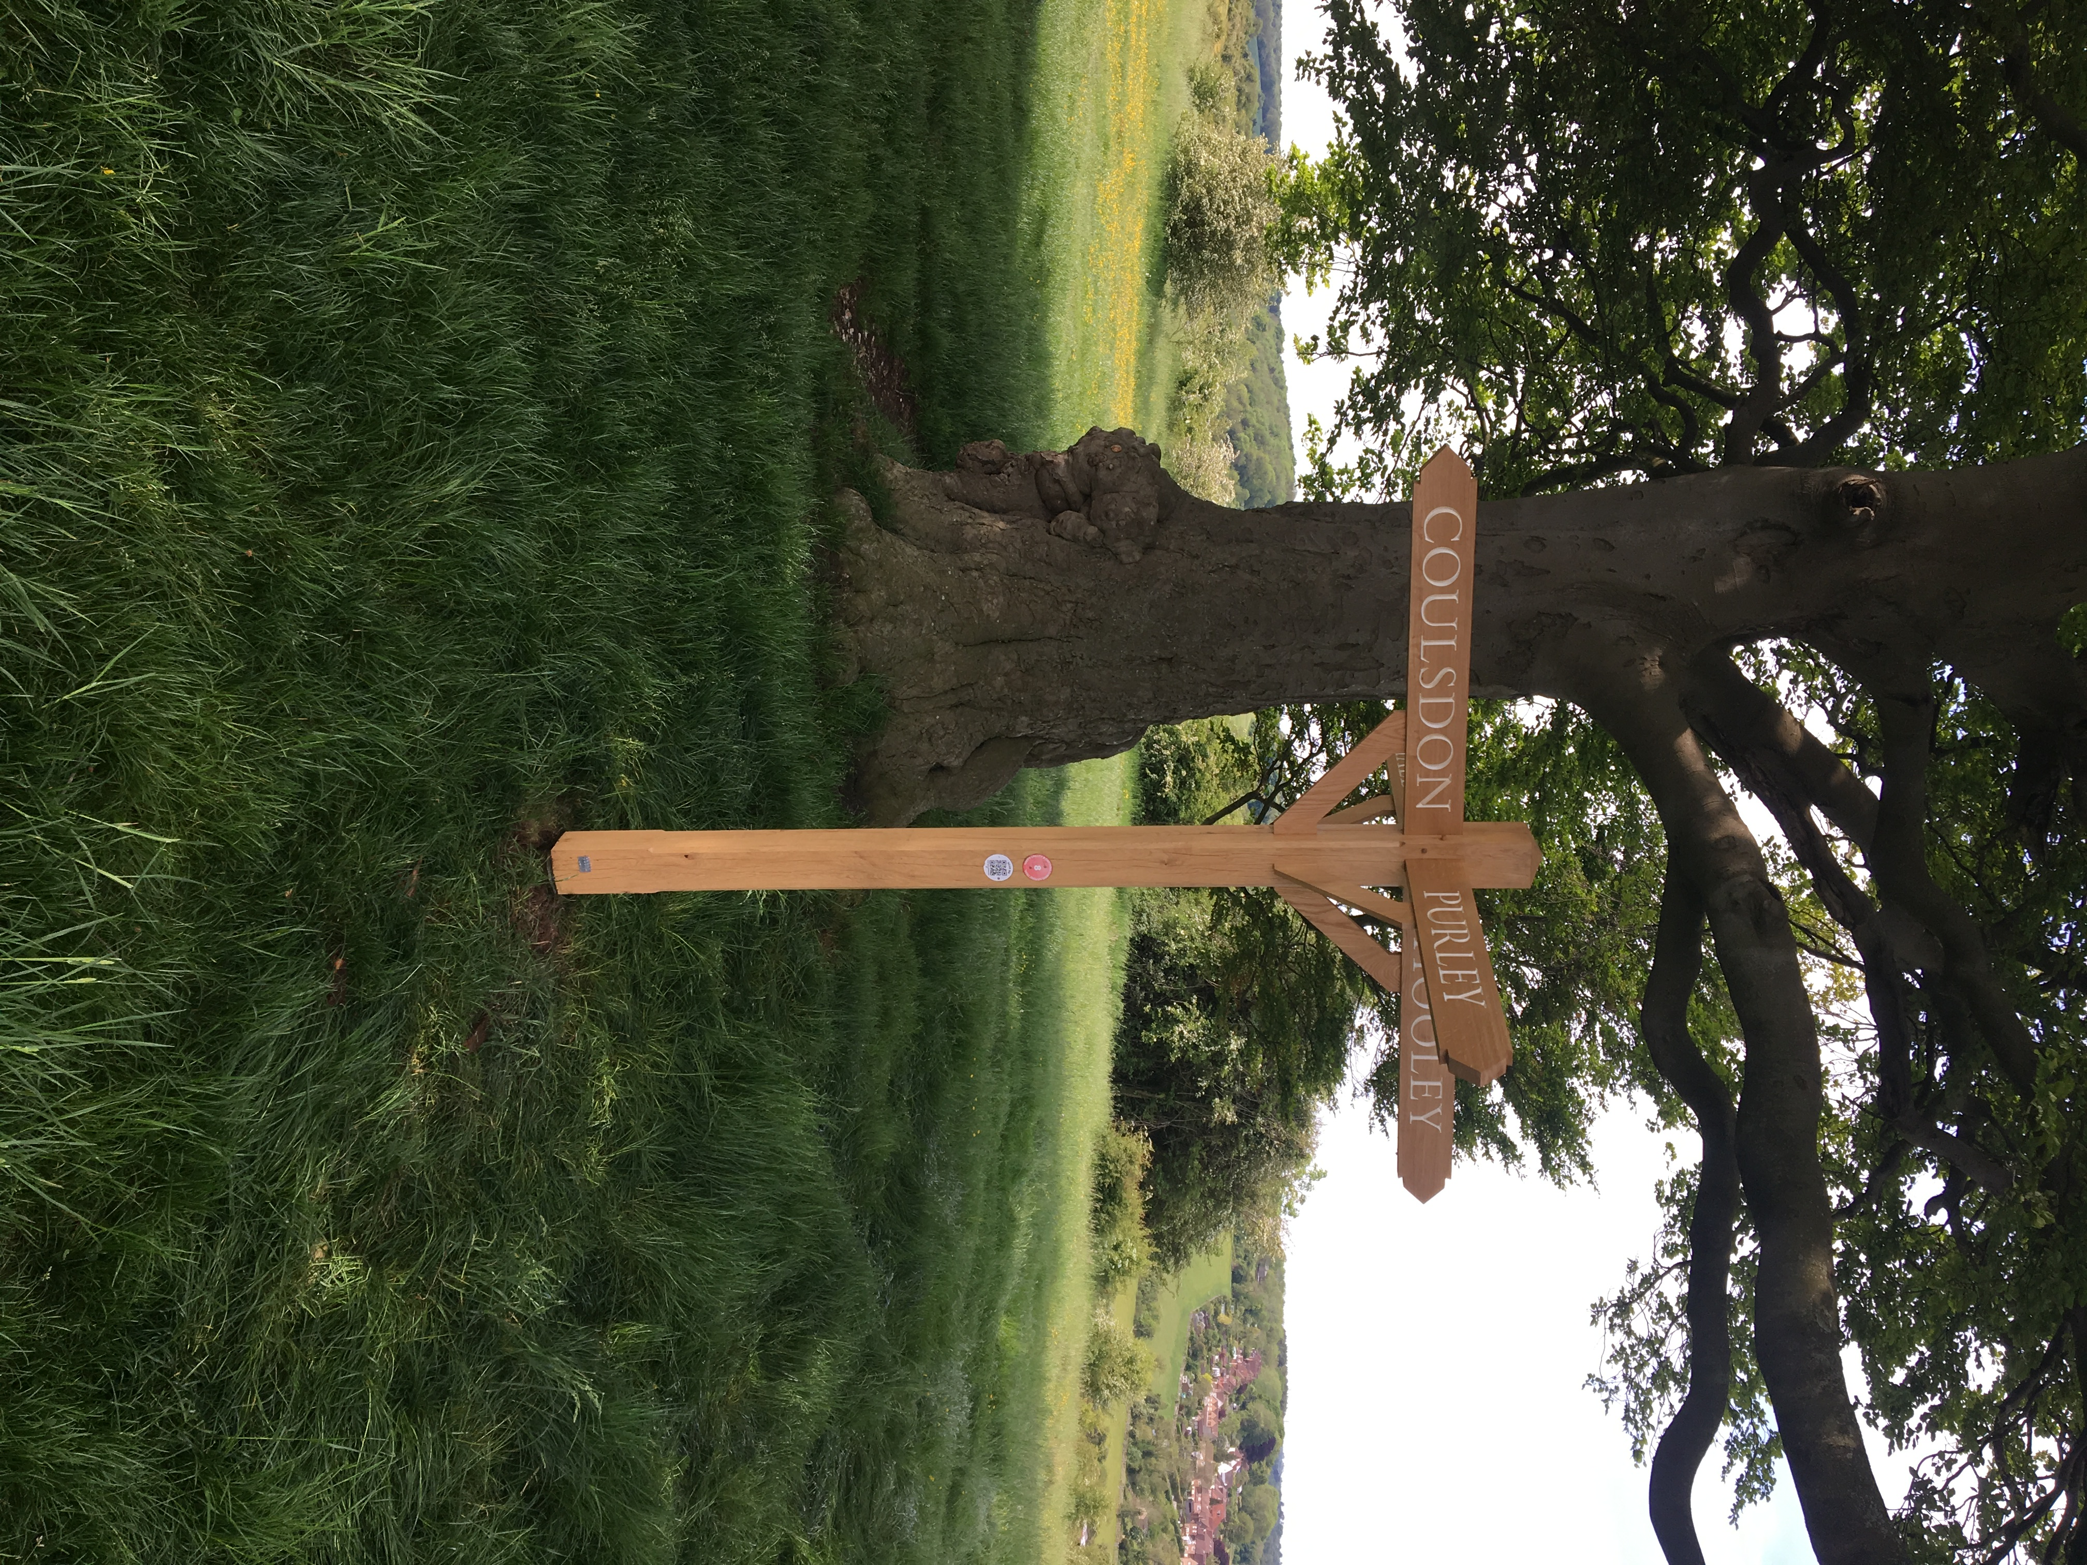 | £750.00
NO. 285 (COULSDON & PURLEY) SQUADRON, AIR TRAINING CORPS | Archery accessory equipment (incl. bags for bows arrow canisters target and junior bows) and banner equipment incl gloves flag carrier belting fastening brass, banner case and flagpole holder. In use by cadets. Photos awaited. | £2257.27
OLD COULSDON CENTRE (FOR THE RETIRED) | Security cameras _Protection from unwanted intruders or vandalism .Now installed | £950.00
OLD COULSDON CUPCAKES- HANGING FLOWER BASKETS ON OLD COULSDON PARADE | To provide and enhance hanging flower baskets on Old Coulsdon shopping Parade | £1,500.00
SOUTH EAST CANCER HELP CENTRE | The South East Cancer Help Centre provides services to patient and family members affected by cancer. This will support counselling, bereavement and many other therapies aimed at exploring ways in which individuals can cope with their situation. We also provide a service at CUH.   | £1,000.00
THE CHARTWELL CANCER TRUST | The Chartwell Cancer Trust has teamed up with Croydon Health Services NHS to raise £750,000 to build a new and modernised Oncology Unit, a crucial part of the planned £3m overhaul to integrate Acute Paediatric Services in Croydon University Hospital. Part of £30k paid over by the Conservative Group.  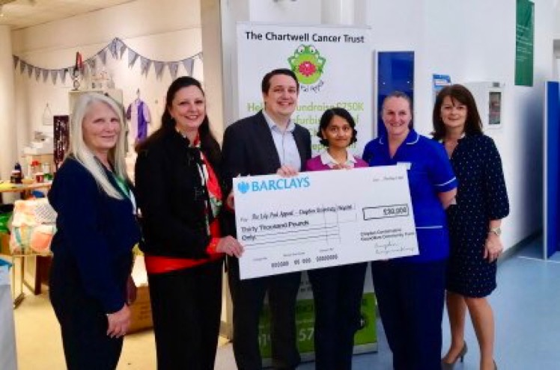 | £2,000.00

